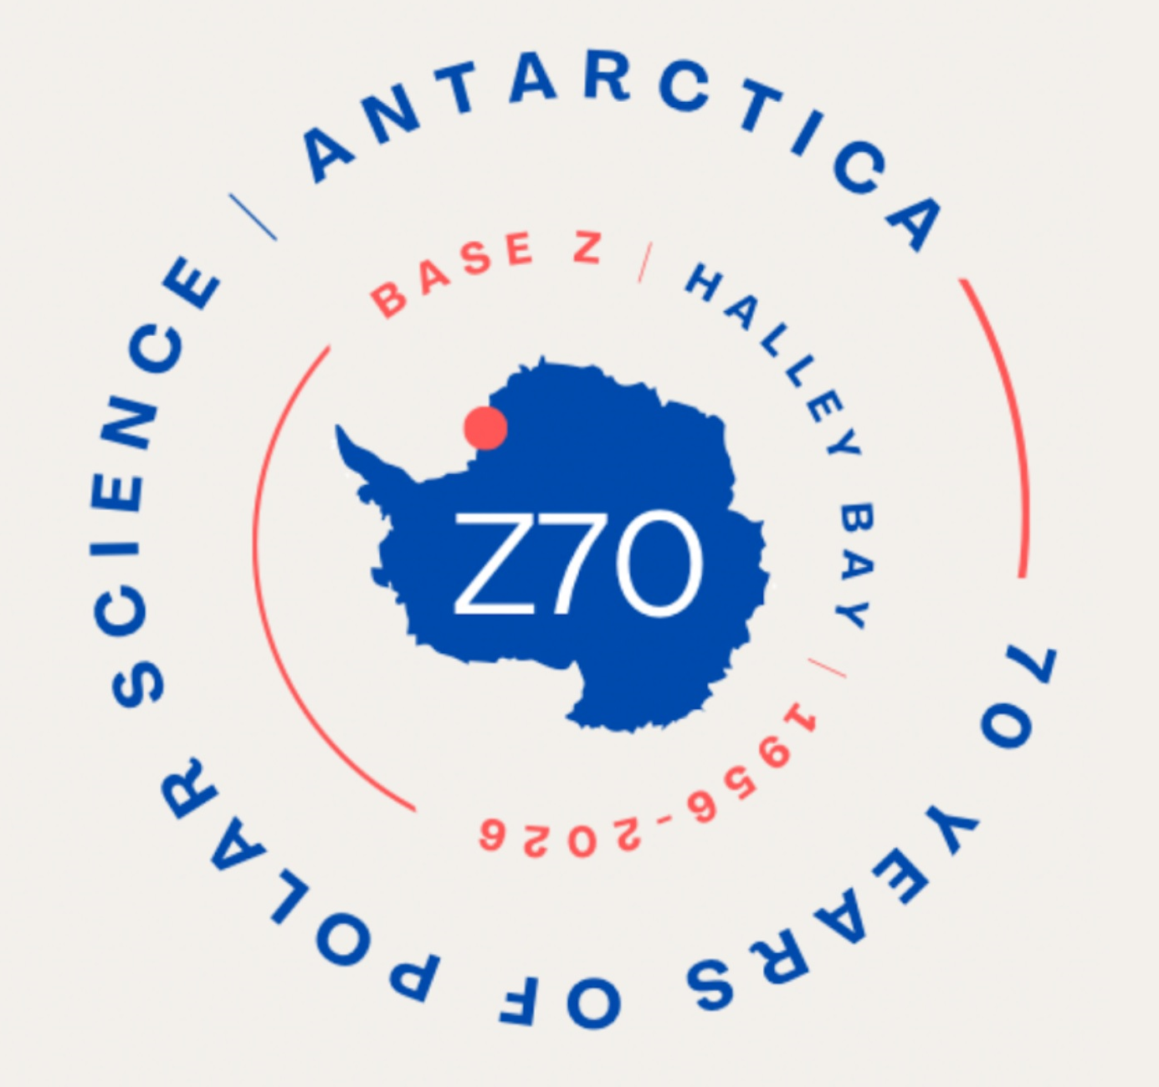 | Z70 Booking Form.  9th - 11th of October 2026  Northampton Town Centre Hotel, Northampton, NNI 2TA

To celebrate 70 years of Halley (Base Z) Research Station and Fids, winterers, summer staff, ship and air crews living and working on the Brunt Ice Shelf.
- Gala dinner with VIP guest speaker Director of BAS Professor Dame Jane Francis.
- Specialist speakers.
- Presentations including archive footage and Halley 6 automation.
- Exhibition of books, t-shirts, mid-winters gifts and other memorabilia items.
Booking form
Complete the form and email to z70event@gmail.com or post to John Blunn, The Wing Low House, Loweswater, Cumbria, CA13 9UX. Expect receipt of your form within 28 days.
Your details
Name: _____________________________________
Email: _____________________________________
Telephone: _____________________________________
Address: _____________________________________
Country: __________________________ Postcode/ZIP: ____________________
Full name(s) of guest(s): 1. _____________________________________
2. ____________________________________
Please complete for function badges:
Name/nickname: ______________________________________________
My connection with Halley includes time with BAS/Fids/Morrisons/Other: Post/s:________________________________________
Years:___________________________________
Dietary requirements
Do you or any of your party have any special dietary requirements?
__________________________________________________________________
Any other relevant information?
___________________________________________________________________
Costs and deposit
The cost of the Z70 celebration will be £130 per person.
Includes cost of Saturday evening meal.
A deposit of £40 per person is required. Balance will be requested approximately 6 months prior to the event. If you would prefer to tender full payment now please indicate below.
☐ I enclose a cheque for £___________________payable to “British Antarctic Survey Club”
Or
☐ I have completed an online/ BACS transfer for £_____________________directly to ‘British Antarctic Survey Club’.
- Account name; British Antarctic Survey Club
- Account number; 08233772
- Sort Code; 60-04-23
For international payees:
- BIC/SWIFT NWBK GB2L
- IBAN GB34 NWBK 6004 2308 2337 72
If transferring money electronically please insert “Your Surname Z70” as a reference when prompted by your online provider. In addition please email z70event@gmail.com so we can confirm receipt. Deposits will be fully refundable up until 01/01/2026
☐ Please email me a receipt.
Memorabilia
In previous reunions attendees have brought memorabilia along to put on display. Please indicate if you would like to do this so we can book space:
☐ I would like to bring memorabilia for display
Meals
Information about the gala dinner and additional meals will be sent out closer to the event.
Volunteering
Attendees (and their partners) helped make Z50 and Z60 the successful events they were. We are looking for volunteers to plan or help out at the weekend. If you can spare a couple of hours please indicate below what time and activity best suits you.
☐Friday evening ☐Saturday morning ☐Saturday afternoon ☐Sunday morning
☐Setup/takedown ☐Merchandise ☐Reception ☐Other
We are also looking for year and group representatives to spread the word before the event and gather people together at specific times during the weekend. We already have volunteers for some years but have gaps to fill. We would be especially interested to hear from members of summer teams, non-BAS personnel (e.g Morrisons) and ship’s crew.
☐ I would like to volunteer as a year or group representative for year(s)__________________
If you would like to help towards the weekend planning email z70event@gmail.com
Accommodation
Z70 have reserved an allocation of rooms at the Northampton Town Centre Hotel: https://all.accor.com/hotel/C0W3/index.en.shtml. To book a room please email the hotel on hc0w3-RE@accor.com or call 01604 739 988 Option 1 for Reservations
Quote ‘Z70 Allocation’
Costs are:
£110 single occupancy including breakfast
£120 double occupancy including breakfast
GDPR
Your name and contact details will be kept by the Z70 committee for the purposes of organising the Z70 reunion. Your name and contact details will be passed to future Halley Reunion organising committees. If you wish to have your name and contact details removed from the databases after the Z70 reunion please let the committee know.
Conference list
If you would like to be included on the attendance list published on the Z70 webpage please state how you would like your attendance to be recorded (eg. name, nickname and/or role/year):
____________________________________________________________________

